**OS process in JMeter:**

Tread group-add-OS process sampler

OS process sampler is used to give commands and fetch the data from machine.

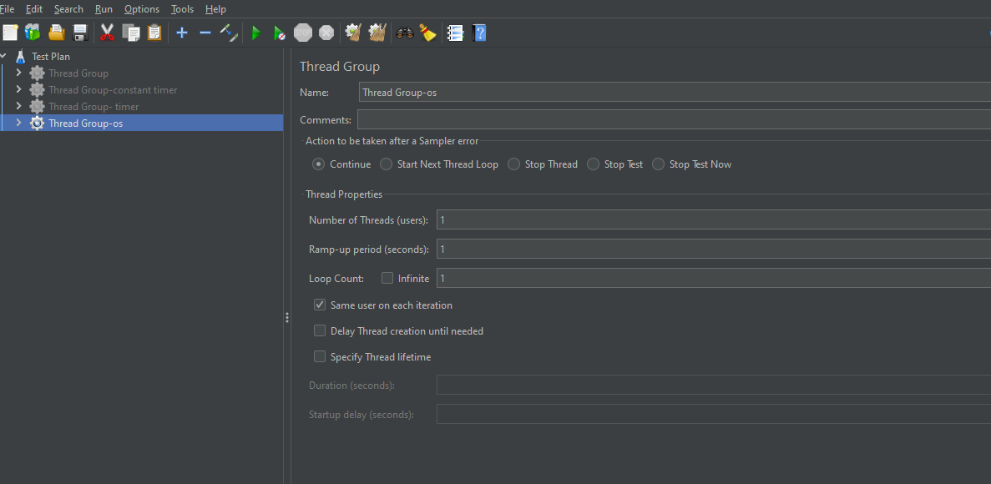

I gave command as ipconfig.

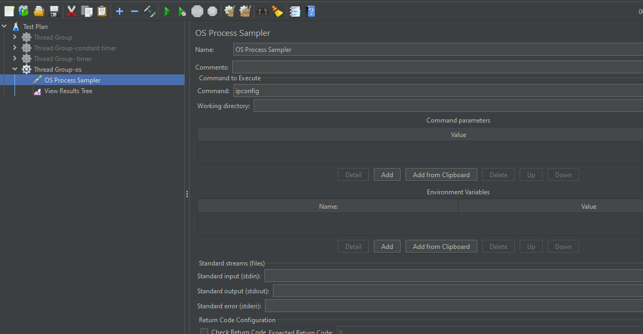

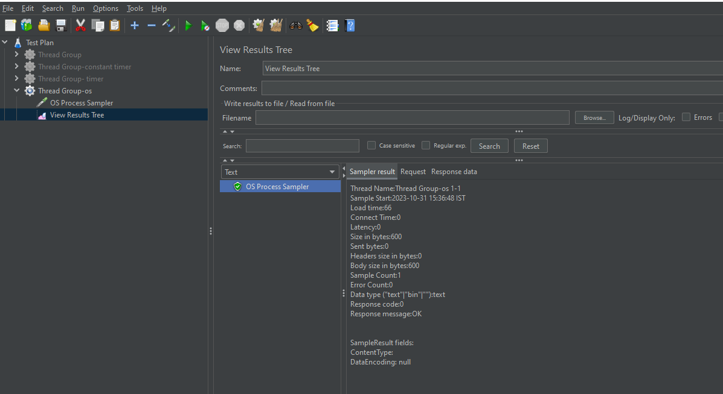

The above we can see the configuration of my machine.